(Approx. 1002 words)

Two Ways to Add Style to a Word Document
By Nancy DeMarte, 1st Vice President, Sarasota Technology Users Group, FL
June 2019 issue, STUG Monitor
www.thestug.org
ndemarte (at) verizon.net

Microsoft Word is loaded with features that give style to documents. “Style” in this case means modifying the look of text and paragraphs. To do this, many users change the font or font size, add effects like bold or color and maybe change the space between lines. These changes are made one at a time and can be time-consuming. Plus, you’ll have to do it again the next time you want that style.

There are tools, however, that add style in easier and more coordinated ways. The first one is on the Home tab > Styles group. This gallery contains what could be called “Style Parts” because they add style to parts of documents like titles and headings. The other style-adding feature is the Document Formatting group on the Design tab. This gallery lets you apply a group of stylistic features to a document all at once. These are called “Style Sets.” Here are a few tips for using Style parts and Style sets.

Style Parts:
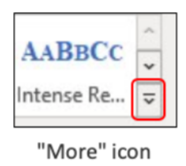
The Styles group on the Home tab offers several styles which can be applied to parts of documents or used to create a special kind of document, like a company or club logo. To see the entire Styles gallery, click the More icon at the right end of the Styles group. Let’s say you have a document with headings above each paragraph, as this article has. You would like to give them a different appearance from the rest of the text. To preview how some options would look, select your first heading and move your mouse pointer over the styles in the gallery to see how they change the heading. When you find one you like, click it to apply the style to the first heading.

But what about all the other headings in your document? This is where Format Painter can help. Select the heading to which you just applied a style. Then double click Format Painter on the Home tab > Clipboard group to keep Format Painter enabled. Drag your mouse across each of the remaining headings to apply the same style as the first one. When done, click Format Painter once to turn it off and save the document. I created and applied a style to the headings in this article as an example. It has a different font, font size, and color from the rest of the text.

Modify or Create a New Style:
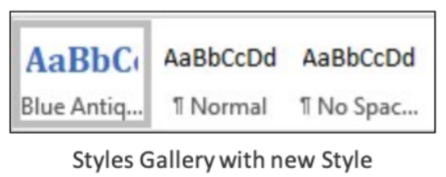
Sometimes, you won’t find the style part you want in the gallery. This is when you can change a gallery style or make your own. To create a new style and add it to the gallery for future use, open a document and select a heading. Using the tools in the Home tab > Font group, make your changes. With the newly styled text selected, click the More icon and then click ‘Create a Style’ to open the ‘Create New Style from Formatting’ box.

Give the new style a name that relates to its features and click OK. Your new style will appear in the Styles gallery. I named my heading, “Blue Antique Heading,” based on the font I used. If you don’t find your new heading style in the gallery, click the More icon again, click Apply Styles and then click the new heading style name. Now should see it in the gallery.

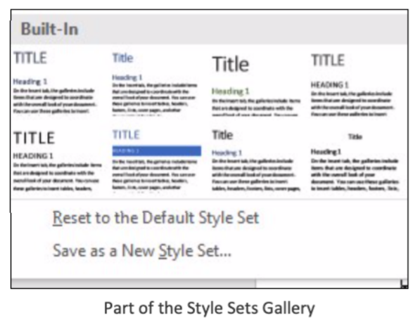
Style Sets:
You can apply a group of style features to a whole document at once using Style Sets. This includes features on the Home tab in the Font and Paragraph groups. In Word version 2013 and later, Style sets are found on the Design tab. Open this tab and click the More icon at the right end of the Document Formatting group to see the built-in style sets. Preview how these would look on your document by clicking anywhere in the document and moving your mouse pointer slowly over the gallery. Click a set to apply it to your document. If you change your mind, remove the style by clicking the Undo icon (a left-curving arrow at the top left above the ribbon) or pressing Crtl+Z on the keyboard.

For those with Word 2007 or 2010, the steps differ a bit. Click the Home tab, and in the Styles group, click Change Styles, then point to Style Set. Preview it the same way as described above. Then click a style set to apply it to your selected document. Set a

Style Set as Default:
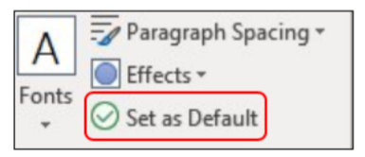
The default style set in Word is called Normal. This means whenever you type in a blank document, all the features of the Normal style set will be used. If you wish to modify the Normal style, make your changes, but give it a new name, which will leave the Normal style set intact. We do this so it doesn’t cause a problem when you open older documents. Microsoft has changed its Normal style properties over the years. (For example, Arial was at one time the default font; now it’s Calibri.)

You can choose any Style set to become the default. First, apply all the features you want. Then preview how it would look and add it to the Document Formatting gallery. Finally, click its gallery thumbnail, and click “Set as Default” which appears at the right end of the Document Formatting group. Now all new documents will be formatted according to your default Style set. You can change the default style at any time.

The way to master Styles is to start small, such as applying headings or titles using the Styles gallery on the Home tab. After Microsoft changed the default line spacing from 1.0 (single space) to 1.15, I created a style that was single-spaced. That was the only change I made to the Normal style, but it comes in handy when I want to save space.

